# 1
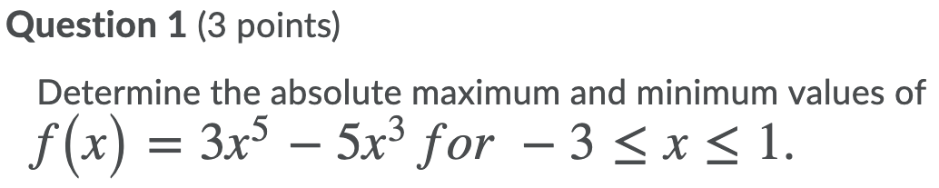
The derivative is
$$f '\left(x\right)=15x^{4}-15x^{2}$$
Next, we solve $f '\left(x\right)=0$
$$15x^{4}-15x^{2}=0$$
$$15x^{2}\left(x^{2}-1\right)=0$$
$$15x^{2}\left(x-1\right)\left(x+1\right)=0$$
Equating each factor to zero gives $x=-1$, $x=0$, or $x=1$
Next, we evaluate the function at $x=-1$, $x=0$, or $x=1$ and at the endpoints $-3$ and 1.
$$f\left(-1\right)=3{\left(-1\right)}^{5}-5{\left(-1\right)}^{3}=2$$
$$f\left(0\right)=3{\left(0\right)}^{5}-5{\left(0\right)}^{3}=0$$
$$f\left(1\right)=3{\left(1\right)}^{5}-5{\left(1\right)}^{3}=-2$$
$$f\left(-3\right)=3{\left(-3\right)}^{5}-5{\left(-3\right)}^{3}=-594$$
We conclude that the absolute maximum value of the function over the interval $-3≤x≤1$ is
$f\left(-1\right)=2$ and the absolute minimum value is $f\left(-3\right)=-594$

# 2
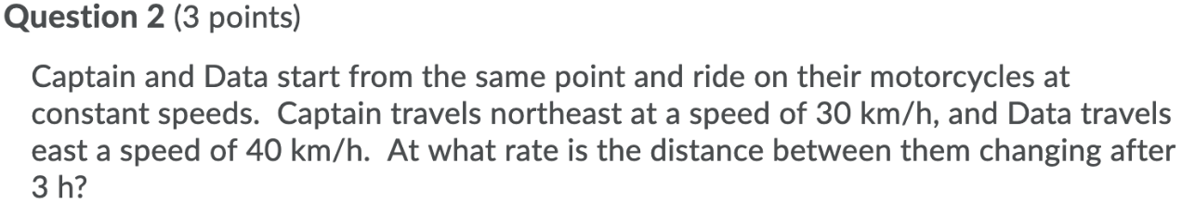
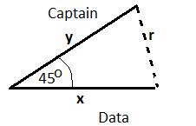
Using Cosine Law,
$$r^{2}=x^{2}+y^{2}-2xy cos {45}^{0}$$
$r^{2}=x^{2}+y^{2}-xy \sqrt{2}$ because $cos {45}^{0}=\frac{\sqrt{2}}{2}$
Next, we differentiate both sides with respect to time $t$
$$2r\frac{dr}{dt}=2x\frac{dx}{dt}+2y\frac{dy}{dt}-x\sqrt{2} \frac{dy}{dt}-y\sqrt{2} \frac{dx}{dt}$$
After 3 hours, Captain has travelled for $y=3×30=90 km$ and Data has travelled for $x=3×40=120 km$
Since $r^{2}=x^{2}+y^{2}-xy \sqrt{2}$ , then after 3 hours
$$r^{2}={120}^{2}+{90}^{2}-\left(120\right)\left(90\right) \sqrt{2}$$
$$r^{2}=22500-10800 \sqrt{2}$$
$$r=\sqrt{22500-10800 \sqrt{2}}$$
$$r=30\sqrt{25-12 \sqrt{2}}$$
Next substitute this value and the speeds $\frac{dx}{dt}=40$ and $\frac{dy}{dt}=30$ in the equation
$$2r\frac{dr}{dt}=2x\frac{dx}{dt}+2y\frac{dy}{dt}-x\sqrt{2} \frac{dy}{dt}-y\sqrt{2} \frac{dx}{dt}$$
$$2\left(30\sqrt{25-12 \sqrt{2}}\right)\frac{dr}{dt}=2\left(120\right)\left(40\right)+2\left(90\right)\left(30\right)-120\sqrt{2} \left(30\right)-90\sqrt{2} \left(40\right)$$

$$\frac{dr}{dt}=\frac{2\left(120\right)\left(40\right)+2\left(90\right)\left(30\right)-120\sqrt{2} \left(30\right)-90\sqrt{2} \left(40\right)}{2\left(30\sqrt{25-12 \sqrt{2}}\right)}$$
$=\frac{250-120\sqrt{2}}{\sqrt{25-12 \sqrt{2}}}$
$≈28.33626$ km/h

# 3
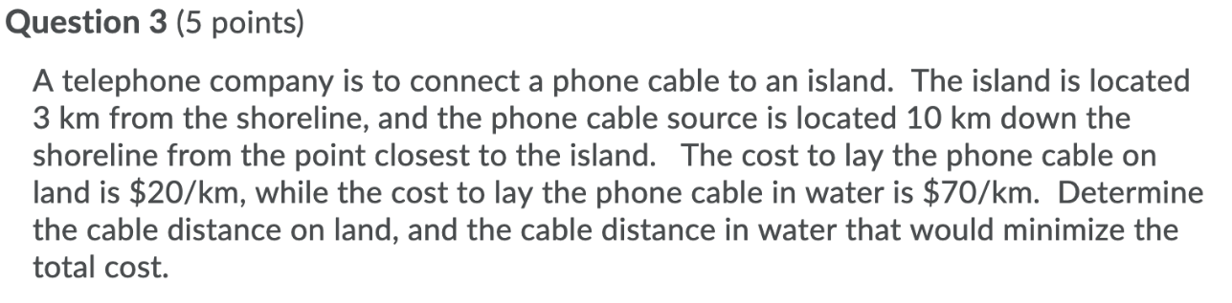
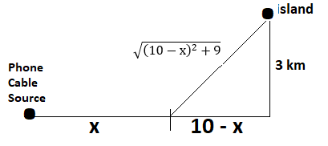
We want to minimize the total cost
$C\left(x\right)=20x + 70\sqrt{x^{2}-20x+109}$ where $0≤x≤10$ because the distance $10-x$ cannot be negative
Differentiating the cost function,
$$C '\left(x\right)=20+\frac{ 70\left(2x-20\right)}{2\sqrt{x^{2}-20x+109}}$$
$$C '\left(x\right)=20+\frac{ 70\left(x-10\right)}{\sqrt{x^{2}-20x+109}}$$
Next, we solve $C '\left(x\right)=0$
$$20+\frac{ 70\left(x-10\right)}{\sqrt{x^{2}-20x+109}}=0$$

$$20\sqrt{x^{2}-20x+109}+70x-700=0$$
$$20\sqrt{x^{2}-20x+109}=-70x+700$$
Divide both sides by 10
$$2\sqrt{x^{2}-20x+109}=-7x+70$$
Square both sides
$$4x^{2}-80x+436=49x^{2}-980x+4900$$
$$45x^{2}-900x+4464=0$$
Divide both sides by 45
$$x^{2}-20x+\frac{496}{5}=0$$
$$x^{2}-20x=\frac{-496}{5}$$
$$x^{2}-20x+100=\frac{4}{5}$$
$${\left(x-10\right)}^{2}=\frac{4}{5}$$
$$x-10=\frac{±2\sqrt{5}}{5}$$
$x=10-\frac{2\sqrt{5}}{5}$ because x cannot exceed 10

Next, we evaluate $C\left(x\right)=20x + 70\sqrt{x^{2}-20x+109}$ at $10-\frac{2\sqrt{5}}{5}$ and at the endpoints 0 and 10
$$C\left(10-\frac{2\sqrt{5}}{5}\right)=20\left(10-\frac{2\sqrt{5}}{5}\right)+ 70\sqrt{{\left(10-\frac{2\sqrt{5}}{5}\right)}^{2}-20\left(10-\frac{2\sqrt{5}}{5}\right)+109} ≈401.25$$
$$C\left(0\right)= 70\sqrt{109}≈730.82$$
$$C\left(10\right)=200 + 70\sqrt{100-200+109}=410$$
We conclude that the cable distance on land is $10-\frac{2\sqrt{5}}{5}≈9.1056 km$ and the cable distance in water is $\sqrt{{\left(10-\frac{2\sqrt{5}}{5}\right)}^{2}-20\left(10-\frac{2\sqrt{5}}{5}\right)+109} ≈3.13 km$minimize the total cost

# 4
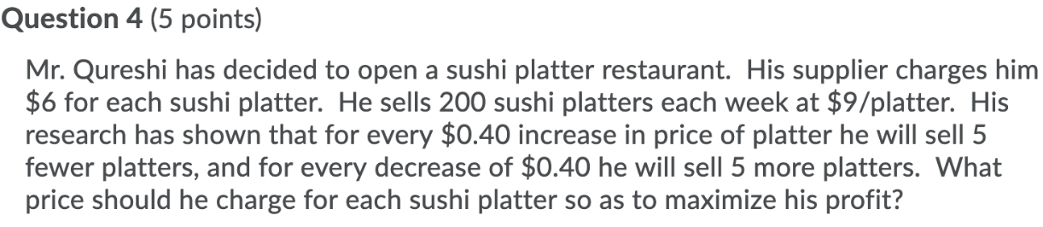
Let x = # of $0.40 increases in price
We want to maximize the revenue function
$$R\left(x\right)=\left(200-5 x\right)\left(9+0.40 x\right)$$
$R\left(x\right)=-2x^{2}+35x+1800$ for $-22.5≤x≤40$ to make the revenue non-negative
Differentiating
$$R '\left(x\right)=-4x+35x$$
Solve $R '\left(x\right)=0$
$$-4x+35=0$$
$$x=35/4=8.75$$
$$R\left(-22.5\right)=0$$
$$R\left(40\right)=0$$
$$R\left(8.75\right)=1953.125$$
We conclude that the price of each sushi platters should be
$$9+0.40 \left(35/4\right)=\$12.50$$

